Business Requirements Specification: DocuMind Enterprise
Project Codename: DocuMind Enterprise Date: March 10, 2026 Version: 1.0

Content Summary

1. Executive Summary --------------------------------------------------------------------4
- 1.1 Project Overview: Definition of the RAG-based SOP Assistant.
- 1.2 Problem Statement: Addressing inefficiencies in manual document retrieval.
- 1.3 The Solution: Implementation of the "Context-Aware Corporate Brain" (RAG).

2. Business Objectives & Scope ---------------------------------------------------------5
- 2.1 Core Objectives: Accessibility, Accuracy, and Traceability.
- 2.2 Scope Boundaries: In-Scope and Out-of-Scope features (The "In/Out" Matrix).
- 2.3 Stakeholder Analysis: Roles for Sponsors, End Users, and Legal/Compliance.

3. Technical Architecture & Stack (The "LLM Ops" Stack) ---------------------5
- 3.1 Orchestration: LangChain / LlamaIndex workflows.
- 3.2 Infrastructure: FastAPI microservices and Docker containerization.
- 3.3 Data Layer: Pinecone/Qdrant Vector Database and Embedding models.
- 3.4 Model Selection: GPT-4o (Reasoning) and Llama 3/Groq (Fallback).

4. Functional Requirements --------------------------------------------------------------6
- 4.1 Data Ingestion: Parsing (Unstructured.io), Chunking (RecursiveCharacterTextSplitter), and Upsert strategy.
- 4.2 Retrieval & Generation: Hybrid Search logic and citation engine requirements.
- 4.3 Security & Compliance: Prompt injection defense and PII/data isolation.

5. Implementation Roadmap (4-Week Cycle) ----------------------------------------7
- 5.1 Week 1: Ingestion Pipeline (ETL, Chunking, Embeddings).
- 5.2 Week 2: Retrieval Engine (Hybrid Search, Prompt Configuration).
- 5.3 Week 3: Verification Logic (Citations, Refusal Logic).
- 5.4 Week 4: Packaging & UI (Dashboard, Stress Testing, Dockerization).

6. Success Metrics & KPI -----------------------------------------------------------------7
- 6.1 Search Performance: Reducing retrieval time from 15 minutes to <10 seconds.
- 6.2 Accuracy: Maintaining >95% citation accuracy.

7. Glossary & Definitions ------------------------------------------------------------------8
- 7.1 AI/RAG Concepts: Definitions for Embeddings, Hybrid Search, and Zero-Hallucination Constraints.
- 7.2 Technical Terms: Definitions for LLM Ops, Agentic Workflows, and Ingestion Pipelines.

1. Executive Summary

DocuMind Enterprise is an intelligent, RAG-based SOP assistant designed to transform static, unstructured corporate documentation into an interactive knowledge base. This project is part of the Infotact Solutions "Archi01" initiative to move toward agentic, production-grade LLM systems.

Problem
Current internal knowledge management is reactive, inefficient, and prone to error. Staff are forced to navigate 500-page policy PDFs manually, resulting in:
- Productivity Loss: Time wasted on manual search.
- Interpretation Risk: Reliance on outdated or misunderstood policies.
- Compliance Gaps: Lack of verification for current policy versions.

The Solution
DocuMind Enterprise will utilize a Retrieval-Augmented Generation (RAG) architecture to provide natural-language access to internal data, ensuring strict grounding and verifiable citations.
Key Objectives:
- Semantic Retrieval: Moving beyond keyword matching to concept-based understanding, allowing employees to ask questions in plain language and receive precise, context-aware answers.
- Strict Grounding: Implementing a "Zero-Hallucination" architecture where the AI is restricted to answering only based on the ingested corporate data.
- Verifiable Accuracy: Ensuring every response is automatically appended with specific source citations (e.g., document name and page number), enabling instant verification by the end-user.
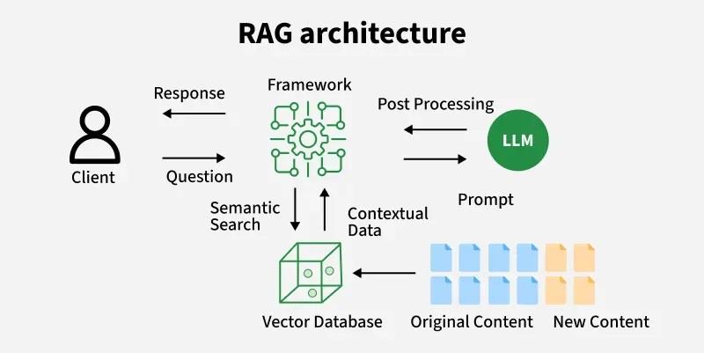

2. Business Objectives
• Accessibility: 24/7 natural-language access to internal documentation.
• Accuracy: Zero-hallucination architecture grounded in verified source material.
• Traceability: Mandatory citation of page numbers and source titles for every AI-generated claim.

3. Scope Boundaries (The "In/Out" Matrix)
- In-Scope: RAG for policy PDFs, citation engine, hybrid search.
- Out-of-Scope: Integration with Slack/Teams (for now), support for non-PDF formats (like video/audio), or external internet research capabilities.

4. Stakeholder Analysis
- Business Sponsor: Who pays for the API costs (e.g., CTO or Head of Operations)?
- End Users: Who asks the questions (e.g., HR staff, new hires)?
- Compliance/Legal Team: Who must sign off on the privacy and redaction logic?

5. Business Rules & Processes
- Example Rule: "If a user asks a question about a 'Termination Policy,' the AI must check the 'HR-Confidential' folder first, regardless of the prompt."
- Workflow: Map out how a user submits a query and how the system validates their access before returning the answer.

6. Assumptions and Dependencies
- Assumptions: "We assume all source PDFs are OCR-readable or formatted in plain text."
- Dependencies: "The project is dependent on the availability of the OpenAI API and Pinecone server less infrastructure."

7. Functional Requirements

7.1 Data Ingestion (The Pipeline)
• Parsing: The system shall utilize Unstructured.io to parse PDF content into clean text, maintaining layout integrity.
• Chunking Strategy: The system shall implement RecursiveCharacterTextSplitter to ensure contextual integrity.
• Advanced Retrieval: The system shall implement "Parent Document Retrieval" or "Hybrid Search" (Semantic + Keyword) to maximize retrieval accuracy.
• Embedding Model: The system shall standardize on OpenAI text-embedding-3-small, with HuggingFace all-MiniLM-L6-v2 as a fallback for budget-constrained environments.

7.2 Retrieval & Generation
• Refusal Logic: The AI must explicitly refuse to answer any query not present in the ingested knowledge base (e.g., "I don't know" or "This is outside my scope").
• Citations: Every response shall be formatted to include source_document and page_number.

7.3 Security & Compliance
• Defenses: Implementation of input sanitization and system-level instruction locking to prevent prompt injection.
• Isolation: The ingestion pipeline shall run within Docker containers to isolate dependencies like PyTorch / TensorFlow

8. Technical Constraints
• Orchestration Framework: LangChain or LlamaIndex.
• Models: GPT-4o for complex reasoning; Llama 3/Groq for high-speed, cost-efficient fallback.
• Vector Database: Pinecone or Qdrant.
• API Framework: FastAPI (Asynchronous).

9. Implementation Timeline (4-Week Cycle)
Week | Focus | Key Deliverable
Week 1 | Ingestion Pipeline | Functional ETL pipeline that parses, chunks, and embeds documents.
Week 2 | Retrieval Engine | Hybrid search implementation and system prompt configuration.
Week 3 | Verification Logic | Citation formatting and "Refusal" logic implementation.
Week 4 | Packaging & UI | Minimal dashboard UI and stress testing.

10. Success Metrics (KPIs)
- Search Time: Reduce time to locate SOPs from "15 minutes" to "under 10 seconds."
- Accuracy: Maintain a citation accuracy rate of >95% (verified by human audit).
- Adoption: Percentage of staff using the tool weekly.

11.Glossary: DocuMind Enterprise

Project-Specific Terms
- DocuMind Enterprise: The official product brand name for the RAG-based SOP Assistant. It is an intelligent knowledge base designed to eliminate manual searching of corporate documents.
- Zero-Hallucination Constraint: A core safety feature requiring the AI to refuse to answer questions if the information is not explicitly present in the provided source documents.
- Ingestion Pipeline: The ETL (Extract, Transform, Load) process used to parse, chunk, and embed source documents into the vector database.

RAG & AI Concepts
- RAG (Retrieval-Augmented Generation): The system architecture where the AI retrieves relevant data from an external knowledge base (your PDFs) to ground its responses, preventing it from relying solely on its internal training data.
- Embeddings: Numerical representations (vectors) of text chunks that capture the semantic meaning of the content, allowing the system to perform conceptual searches rather than just keyword matching.
- Chunking: The process of breaking down large documents into smaller, manageable segments. The project mandates the use of RecursiveCharacterTextSplitter to maintain contextual integrity across these segments.
- Hybrid Search: A retrieval method that combines Semantic Search (understanding the concept/meaning) with Keyword Search (matching specific terms) to maximize retrieval precision.
- Parent Document Retrieval: An advanced retrieval technique used to improve context relevance by retrieving larger "parent" contexts for smaller "child" chunks.

Infrastructure & Technology Stack
- Vector Database (Pinecone/Qdrant): The specialized database used as the "long-term memory" of the AI, storing semantic embeddings for efficient and accurate search.
- Agentic Workflows: Advanced AI operational patterns that involve complex, multi-step planning and decision-making, moving beyond simple API wrappers.
- Unstructured.io: The primary resource specified for the robust parsing of complex PDF layouts to ensure data integrity during ingestion.
- LLM Ops: The specialized orchestration, memory management, and asynchronous processing stack required to build enterprise-grade AI systems.
- Prompt Injection: A security threat where unauthorized inputs are designed to manipulate the AI's behavior. The system includes a sanitization layer to defend against these attacks.

